* Setting up The Git in PowerShell

The Goal is to Kept the User work best to running as quickly as possible

* First Step
  + Download and Git port for Windows

From the link <http://git-scm.com/downloads>

* Second Step
  + Add the Git Binaries to Your System Path Variables
    - This is a most important part without this is Git won’t work with the Windows PowerShell command prompt
    - So the **path** is set to the

**Computer > Properties > Advanced Settings > Environment Variables**

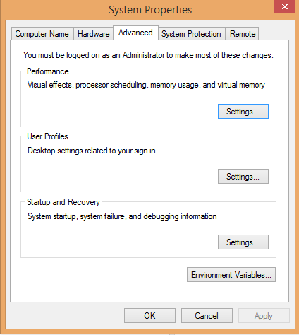

* + - And The Following Path is set to in System Variable to Select **“Path”** see in image and select Edit Button
    - After the **Variable Value** Field Text Box at last **“ ; ”** and the Following path are set see in the Example **c:\%ProgramFiles(x86)%\Git\cmd**

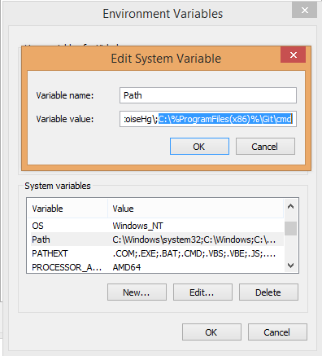

* + - And Also set Path in the PowerShell Command Prompt write like the

**$env:path += ";" + (Get-Item "Env:ProgramFiles(x86)").Value + "\Git\bin"**

* Third Step
  + Download and install posh-Git for better PowerShell and Git integration
    - For that is installed automatically by the Following command



* + - Once the command has completed you should be able to simply run this install command and be finished

